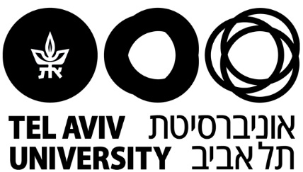

The Lester and Sally Entin Faculty of Humanities

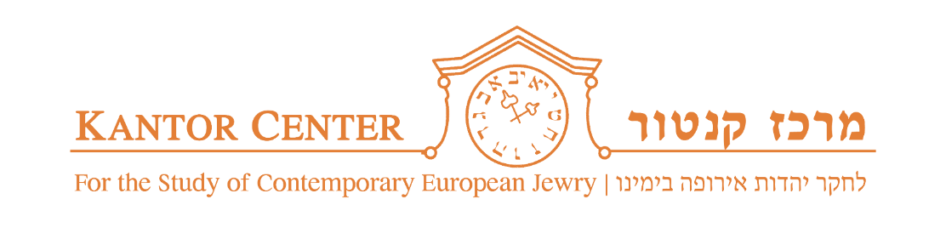

Moshe Kantor Database for the Study of Contemporary
Antisemitism and Racism

Antisemitism Worldwide
2020

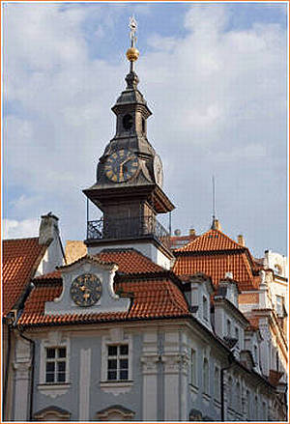

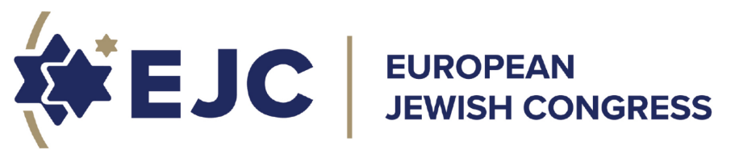
CONTENTS

The Kantor Center Methodology | 3
Lockdown with Keyboards:  Antisemitism Worldwide 2020 – the Corona Year (an overview in English) | 4
Lockdown with Keyboards:  Antisemitism Worldwide 2020 – the Corona Year (an overview in Hebrew) | 20
Graphs | 30
Caricatures | 35

The Kantor Center Methodology

The report is based on the ongoing Kantor Center for the study of Contemporary European Jewry, the Moshe Kantor Database team’s work, and on the various reports and data sent to us by organizations and contact persons in about 40 countries – a network we established during more than 25 years of activity. It should be noted that The Kantor Center and database is the only center, in Israel and abroad, that monitors and analyzes antisemitic manifestations worldwide, according to the same criteria, over such a long period of time that make a multi-year comparison possible. Nevertheless, we are aware of the possibility that not all the relevant data on antisemitic manifestations has reached us, because in many countries monitoring is not consistent or systematic; or because their databases are restricted to free public study because of States’ rules; and because – as all monitoring agencies agree – not all manifestations are reported. Still, we do believe that information about the major manifestations has reached us.

The data and numbers presented herein on major violent antisemitic cases are the result of a specific monitoring and analysis system developed by the Kantor Center team, using specific criteria:
1. proven antisemitic motivation;
2. Counting a multi-event as one case;
3. No exaggeration or diminishing the severity of the situation;
4. Distinguishing between violent cases and verbal and visual manifestations.

Differences might occur between our published data on the number of violent incidents and those released by other monitoring communities and institutes. Monitoring communities and agencies sometimes present numbers of all types of antisemitic manifestations put together, violent, verbal and visual.

We are aware of the necessity to analyze antisemitism in the broadest possible context. Therefore, there can be no understanding of antisemitism without a solid background knowledge of the political, economic and social developments in any given country and in the international arena, and for this we are indebted to our contributors from the world at large.

Lockdown with Keyboards:

Antisemitism Worldwide 2020 – the Corona Year

Abstract
The coronavirus pandemic and the resulting reality dictated both the nature and extent of antisemitism in 2020, which was an unusually tense and turbulent year all over the world. Prejudice, superstition, primordial emotions, and bizarre theories surfaced and dominated the scene, and manifestations of antisemitism, both verbal and visual, were vicious and outrageous.

- Blaming the Jews and Israelis for developing and spreading the coronavirus (or 'Judeovirus'), was the main motif in this year's antisemitic manifestations. This notion is rooted in a deep fear of the Jew/Israeli as a spreader of disease in both the past and present. Iran contributed to the accusation's dissemination.

- Lockdowns reduced encounters between Jews and their ill-wishers, diminishing the number of violent incidents from 456 to 371 - a number typical for 2016-2018. Moreover, no one was murdered this year for being Jewish, although any physical attack might end in a severe or fatal outcome. In most countries a decrease was observed in violent incidents, attacks on both people and property, threats and arson, but the level of vandalism against Jewish property and institutions remained unchanged.

A rise was registered in Ukraine, and a decline in Australia, the UK and especially in France and Canada. Worrying trends continued in Germany and the USA: in Germany a rise was recorded in the total number of incidents, with the opposition to vaccines generating comparisons to the Holocaust, and continued desecration of Jewish memorials and cemeteries; in the US antisemitic activities on the internet have intensified, and focal events like the killing of George Floyd by a police officer, the emergence of the BLM (Black Lives Matter) and Antifa movements as well as the Presidential elections have engendered conspiracy theories and boosted the activities of white supremacists and QAnon.

- Vaccine opponents, both in Israel and abroad, compare the pandemic to the period of the Holocaust, and themselves to the persecuted Jews. This notion peaked with a comparison of Pfizer CEO Albert Bourla to Josef Mengele.

- The lockdown enhanced all types of online activity, impacting the extent of antisemitism: the restrictions imposed on large networking services like Twitter and Facebook, and the commitments they took upon themselves – to erase expressions of hatred, racism and antisemitism, started to reduce the number of antisemitic manifestations on the web. At the same time, both antisemitic and anti-Zionist expressions became fiercer and more accusative, as a result of the pandemic's spread and its dire economic consequences.

- Extremist groups, especially on the far right, such as white supremacists and neo-Nazis, left the open social networks, moving their operations to the clandestine darknet - which is free of any restrictions or supervision. In the darknet, which grew substantially over the past year, they run their own websites, that are very hard to track. Ultimately, the decline that was observed in antisemitic manifestations in the open networks, was accompanied by a rise in antisemitic activities on the darknet.

Another new phenomenon to emerge during the pandemic was zoom-bombing: as zoom became a most common and effective channel of communication, extremist individuals and small groups seized the opportunity and began to break into zoom conferences of synagogues, Jewish community centers and university students, disrupting the meetings and posting their own hate messages instead. The number of such disruptions is hard to quantify.

- The economic crisis resulting from the pandemic significantly lessened the ability of the BDS to inflict financial damage on Israel and Jewish institutions. Instead, BDS has focused its efforts on Lawfare – warfare in the legal arena, as well as support for the Palestinian struggle against the Abraham Accords and Arab-Israeli cultural collaboration.

The trend of accusing Jews and Israelis for spreading Covid-19 waned somewhat in the summer, but was rekindled in the fall, with the advent of the vaccines. In-between, several other important events occurred, like the killing of George Floyd, the emergence of BLM, and the European Court of Justice’s permitting countries to ban kosher slaughtering, reinforcing antisemitic expressions and attacks.

Several important achievements in the battle against antisemitism should be noted, such as the appointment of more special envoys in various countries and institutions, a growing willingness to adopt the Working Definition of Antisemitism, allocation of funds for ensuring the security of Jewish communities, and increased restrictions on the social media. The Kantor Center is currently mapping the adoption of the Working Definition of Antisemitism worldwide, alongside the heated debate that surrounds it.

A detailed overview

- Blaming the Jews and Israelis for developing and spreading the coronavirus (or 'Judeovirus') is a graver accusation than any previously made against Jews throughout history: Today's pandemic is regarded as a present-day Holocaust, a devastating global calamity, that has already killed more than 2.5 million people and caused extensive economic devastation. About a year ago, in February 2020, the pandemic began to spread across the globe, immediately followed by accusations that the virus had been developed and was being spread by Jews and Israelis; they are the ones who would find a cure and vaccine for the disease, selling it to the ailing world and making a huge profit. Over the following months this libel spread rapidly. We received reports to this effect from dozens of countries, in the form of aggressive messages and numerous malicious caricatures. Moreover, the accusation was heard not only from extremist circles, such as white supremacists, ultra-conservative Christians, or the usual accusers like Iran, Turkey and the Palestinian Authority. It also spread to populations with no well-defined political or ideological identities. The Rothschild family and billionaire George Soros, who was previously blamed for bringing the immigrants to Europe, are mentioned repeatedly as partners in the global pharmaceutical industry, funding the spread of the virus and expected to gain even more wealth from it. Haredi Jews were especially targeted, because they were infected in large numbers while disobeying the imposed regulations.
While in the US, for example, accusations mostly target Jews in general and Haredi Jews in particular, in the Middle East, it is Israel, Zionism and the Mossad that are considered responsible for the global situation. Iran has facilitated the dissemination of this accusation: In South America, for instance, Iran has TV and radio networks, such as Hispan TV, that blame Israel, and a Twitter campaign, probably Iranian, equating Israel with the virus, has reached millions of users. Iran's Supreme Leader Ali Khamenei uses his own Twitter account to constantly call for terrorism against Israel and for Israel's annihilation, comparing the country to the coronavirus. Islamist propaganda in general describes Israel itself as the virus that is most dangerous to humanity, naming it Covid-1948, after the year in which Israel was established. IDF soldiers are accused of spreading the virus in the Palestinian Authority, and warders in Israeli prisons are accused of injecting it to prisoners.

- Jews/Israelis as spreaders of disease: The common maxim, that Jews will be blamed anyway for any trouble under the sun, does not suffice in this case. Deep fear of the Jew/Israeli as a spreader of disease in both the past and present, is at the source of the accusation. This is fear of an unknown disease, rapidly spreading, darkly mysterious, and such dread engenders prejudice, superstition and primordial emotions, like those evoked by tuberculosis or leprosy when they had no cure. Throughout history Jews have been perceived as spreaders of disease, ever since they were driven out of Egypt: supposedly the Tribes of Israel had contracted leprosy and infected their surroundings, leading to their isolation and consequent banishment from the Land of Goshen; The accusation of well-poisoning was added in the Middle Ages, during the Black Plague of the mid-14th century, when people looked for someone to blame for the great catastrophe; Jews served as physicians in the courts of kings and princes, and many legends reflect fear of their great power and knowledge; In the USA of the late 19th century Jews were blamed for spreading typhus and cholera; the Nazis were obsessively terrified of Jews as spreaders of disease, describing them as rats, mice and lice, not as a metaphor but as the real thing - Germans would open doors in the ghettos by kicking the door handle with their boots in order not to touch it – and their propaganda spread throughout Europe, as did the propaganda engulfing the so-called 'Doctors' plot' initiated by Stalin toward the end of his life. The term Judeovirus, added to the lexicon this year, effectively encapsulates this fear and the reemergence of the Jew's persona as a spreader of disease.

- Figures and trends: The restrictions imposed on populations as a result of the pandemic altered the nature of antisemitic activities: Just like other populations, including anti-Semite activists, Jews were absent from the public space. Many community institutions were closed down, children stayed at home, and consequently no one was murdered this year for being Jewish. The count of bodily injuries decreased from 170 in 2019 to 107 in 2020. Damage to private property was also reduced from 130 to 84 incidents, simply because people mostly stayed at home. On the other hand, a rise was observed in desecrations of Jewish cemeteries and vandalizing of Holocaust memorials and other Jewish monuments – from 77 to 96 incidents, because these sites are open and unprotected. The number of vandalized synagogues also increased from 53 to 63, since being closed, they became easy prey. In the US a gradual rise in violent incidents has been observed for several years, reaching 119 this year, and Germany also saw a significant escalation in the total number of cases, reaching 2,275 (compared to 1,839 in 2019) - the highest number recorded since 2001 - including 59 violent incidents. In both countries, vandalism accounted for most of the incidents. A significant decline was noted in Australia, the UK and especially France, where the Ministry of the Interior and the Jewish Community both reported a drop of 50% in all types of incidents, due to the tight lockdown, as well as Canada, where the number of violent cases dropped by more than a half. Most incidents occurred in countries with large Jewish communities: the US, Canada, the UK, Australia, France and Germany. In all other countries, with the exception of Ukraine, less than 10 incidents (per country) occurred in 2020.

- Antisemitism on the web: Since the public space was shut down during the pandemic, and people stayed at home with their computers, activities in the social media skyrocketed. These included antisemitic activities and messages – which escalated in aggressiveness and verbal abuse. Since countries closed down their borders, greatly restricting exits and entries, discussions on immigrants and immigration, the focus of attention in previous years, were replaced by online discourse on the coronavirus, the economy and who was to blame for the crisis. When zoom became a major means of communication, a phenomenon called zoom-bombing emerged – breaking into zoom conferences of synagogues, Jewish community centers and Jewish students, disrupting the meetings and using the platform to their own hate messages - swastikas, antisemitic presentations or speeches, etc.

The monitoring system of Israel's Ministry of Diaspora Affairs identified more than a million antisemitic posts in English during 2020, as well as about a million in other languages – including approximately 500,000 in Arabic and 250,000 in French. This marks a drop of about 50% compared to 2018, achieved through agreements with the leading media companies. There is, however, a downside to this improvement: the decrease of antisemitism in the leading networks led to a strengthening of undercurrents – namely, the darknet. Analysis of darknet's contents reveals that while in the open networks about 70% of the antisemitic messages deal with new antisemitism, and about a quarter express classic antisemitism, this ratio is reversed in the darknet: about 70% manifest classic antisemitism and only about 20% display new antisemitism. Possibly users, particularly in the US and UK, came to regard the new antisemitism in the open networks, including antisemitic descriptions of Israel, emphasis on Zionist conspiracies and discussions on the BDS, as more political and not truly antisemitic - and thus more legitimate than classic antisemitism, and certainly more than support for Nazi ideology or the denial or distortion of the Holocaust, both of which have risen over the past year.

- The darknet and extremist groups in the US: As noted above, 2020 saw an advancement in legislation, restrictions and agreements between international institutions that monitor and combat antisemitism and the large networks, especially in the West. Other countries, such as Russia, China, Iran and some Arab countries, did not sign such agreements, and have their own platforms. The restrictions led extremist groups to leave the open networks, and descend into the dark or alternative net, where they can be free of any supervision or restrictions. Quite a number of websites host these groups, changing their names and entrance procedures to prevent exposure. Thus, for example, CHAN 8 became KUN8, where right-wing extremists feed each other with materials they prefer, such as The Turner Diaries - a dystopian novel describing a violent race war in the US, which ultimately annihilates all non-whites in the world. The FBI has defined this novel as the Bible of the racist right: the perpetrators of the terror attacks near San Diego, in Christchurch, New Zealand, and also in Halle and Vienna, drew inspiration from this book, while finding the contacts and training they needed on the darknet. Trafficking of arms, women, pedophilia and pornography also takes place in the clandestine darknet, and Iran has its own darknet station, Press TV, that also spreads its messages out in the open.

One major example of the growing presence of extremists in the darknet is the QAnon movement. Launched in 2016, QAnon has gradually expanded, and by 2020 it had acquired a wide audience of supporters. This far-right movement, defined by the US Department of Homeland Security as a potential source of domestic terrorism, is founded upon a bizarre conspiracy theory, whereby a secret cabal of pedophilic and cannibalistic Satan-worshippers is running a global child sex-trafficking ring and even devouring the children(!). According to some American media, QAnon has acquired millions of followers and fans, because it presents an image of a cosmic struggle between a cult striving for world domination through the Democrats (QAnon's sworn enemies), blacks, and Jews on one side, and the true patriots who support Donald Trump and defend the foundation on which the US was built, as they see it, on the other.

Before the last presidential elections, some of QAnon's spokespersons advocated violence if their opponents should win, and in fact members of this group stood out in the storming of the US Capitol. Even though the Jews are not at the top of their list, but rather all those who do not fit into their worldview, the familiar motifs are quite clear – murdering children and using their bodies. In effect this is just one more version of the blood libel and the evil force striving for world domination behind the scenes: Cabal is a term used in antisemitic and other conspiracy theories to signify a dark, secret body with evil powers. The storming of the Capitol was closely followed by a wave of extreme antisemitic and anti-Zionist expressions in the unsupervised networks, including death threats, calls for the f---g Jewish rats to leave "our country", and letting the Zionists know that they, the patriots, would not allow a hostile takeover of the White House. The acronym ZOG, a known derogatory term used by the American far right, which stands for Zionist Occupation Government, meaning that the Zionists run the US government, has also been restored by QAnon.

- Vaccine opponents and the Holocaust, in Israel and abroad: Since the pandemic is perceived as a terrible catastrophe, it is compared to the worst disaster the world has ever known – the Holocaust. This comparison is especially prevalent among vaccine opponents, who equate the restrictions and lockdowns for containing the pandemic with policies of the Nazi regime. Establishment and governments are accused of applying means of coercion: lockdowns are compared to incarceration in ghettos and concentration camps; vaccines are described as wicked medical experiments; certificates granting privileges after vaccination are seen as the infamous 'selection' procedure in Nazi death camps; antivaxxers feel that they are as undesirable and persecuted as the Jews were; the epitaph on the gate to Auschwitz served as a source for the new slogan 'The vaccine sets one free'; and so on. In Germany, where opposition to the vaccines is particularly strong, demonstrators wore a yellow star on their clothes, with the word 'unvaccinated' replacing the word 'Jew', and called Chancellor Merkel a Nazi. Opposition to the vaccines has generated social and political tension, partly because it comes from groups that either oppose or don't recognize the establishment, like the Haredim in Israel, or from people who define themselves as outsiders who don't follow the rules, largely left-wingers. Far-right supporters of former President Trump also held similar views. The word 'Auschwitz' was observed on a black T-shirt worn by someone in the crowd that stormed the US Capitol. The words 'Auschwitz', 'Josef Mengele' and others also appear on many posters, caricatures and illustrations, both in Israel and abroad. Prof. Galia Rahav, Head of the Infectious Disease Unit at the Sheba Medical Center was called a Nazi, and a newspaper in Greece published the picture of Albert Bourla, a Greek Jew and CEO of Pfizer, next to a picture of Mengele. The advent of the vaccines, coupled with Israel's vast vaccination campaign, assisted by Israelis and Jews who hold prominent positions in the companies that produce these vaccines, like Bourla and Tal Zaks, Chief Medical Officer at Moderna, reinforced the accusations: Israelis and Jews join hands so that Israel may be first to recover from the pandemic, while the rest of the world stands in line and begs the Jews for help.

- Impact of major events: During the summer of 2020 the wave of accusations seemed to wane. They appeared less frequently, and the traditional outbreaks of violence were not observed during the Jewish holidays. The accusations were, however, renewed in the fall, with the emergence of the vaccines. In fact they had not disappeared, but had been replaced by others: Right after the killing of George Floyd by a police officer in Minneapolis in May, the content of accusations against Jews and Israelis, both individually and collectively, changed from one day to the next: First, the slave traders who had shipped hundreds of thousands of Africans to the US, were allegedly Jews, 'privileged' then as now, closely connected to the ruling class, financially benefiting from these ties and holding key positions. In this way, a continuity was established between the image of the Jew in previous centuries and the Jews of today. This accusation, totally lacking any historical foundation, divided the Afro-American public from the Jewish community – in complete contrast to the fact that many Jewish leaders and youth took part in the Afro-Americans' struggle for civil rights. Moreover, the Black Lives Matter movement, emerging after the killing of George Floyd, which was originally non–violent and won the support of the Jewish public, later exhibited antisemitic views in its slogans and demonstrations. Examples include the June protests in Paris, which merged with pro-Palestinian demonstrations, as well as outbursts of vandalism in American cities, that became the order of the day. Second, the allegedly fact-founded news that the Israel Police train American policemen, goading them towards ruthlessness and racism, spread quickly. This notion turned the existing collaboration - combating terrorism and sharing intelligence - into a means for allegedly imbuing American police with the ugly traits of Jews/Israelis, suggesting that Israelis are able to impact forces much larger than themselves. Third, the comparison between Palestinians and Afro-Americans also came up immediately – implying that both populations suffer from the cruelty of Israel and its Jewish supporters, and that this similar, dual oppression is enabled by the close alliance between Israel and the US government.

- The Antifa movement joined forces with BLM and BDS. This movement, which comprises a variety of groups and networks, first originated in the 1930's, focusing on an aggressive struggle against far-right extremism and racism in all their forms. Its activists advocate the strongest opposition to the West in general and capitalism in particular, and being mostly extreme far-leftists, they are ardent anti-Israelis. They side and operate with BLM, they are at the spearhead of BDS, and have voiced support for Palestinian terror and violence in US campuses.

- In December, toward the end of the year, another issue surfaced: the declaration of EU's Court of Justice in Luxembourg permitting states to ban both kosher slaughtering and Muslim Halal. A little earlier, in September, the same Court had announced that it was committed to freedom that would enable both Jews and Muslims to live by the customs of their respective faiths, and in November the EU Council published a long, even moving declaration denouncing antisemitism. But both these important declarations contrast with the image of the Jew, as reflected in the ban on kosher slaughtering: once again the Jews' alleged innate cruelty emerges, a legacy derived from the Old Testament with its jealous and vengeful God, Who commands His followers to raise a strong arm, this time against helpless animals. This cruelty goes hand in hand with yet another characteristic – namely the dogmatism reflected in adherence to age-old halachas, that should long ago have been changed and adapted to a modern world that regards the treatment of animals as a measure of values and compassion. The inversion typical of antisemitism is clear: In the Middle Ages the Jews were accused of having an affinity, even intimate relation, with pigs; using blood is prohibited in Judaism, because 'blood is the soul', but blood libels continued into the 20th century; and kosher slaughtering was publicly denounced as hurtful to the animal, even though the European public is quite ignorant of its procedures. One horrible image engraved in the Germans' collective memory comes from the 'The Eternal Jew', a film produced at Goebbels' command: a line of bearded Jews with knives in their hands and an evil grin on their faces, a cow slaughtered, twitching in agony for long moments as its blood pours onto the floor. Germans weren't the only ones to see this film, which came to symbolize Jewish cruelty toward animals. Like all Nazi propaganda, it was distributed throughout Europe. So the ban on kosher slaughtering may not be antisemitic per se, but it does reinforce this negative image of the Jew.

- The activities of the BDS (Boycott, Divestment and Sanctions) were impacted by both the pandemic and the political changes in the Middle East - mainly the normalization of relations between Israel and several Arab states, and the signing of the US-sponsored Abraham Accords. The impact of the pandemic and economic slowdown was reflected in a significant decrease in anti-Israeli economic initiatives. Even the US publication of a blacklist of companies operating beyond the green line did not increase their number. On the other hand, support for the activities of anti-Israeli students and Palestinian boycott initiatives was continued. Support for the Palestinians, who consider themselves wronged by the Abraham Accords, led the BDS to oppose normalization – in contradiction to its spokespersons' declarations about wishing for peace and prosperity in the Middle East. In this context, most boycott initiatives targeted Arab performers who appeared in Israel or together with Israeli performers. These boycotts engendered a heated debate in Israel's Arab sector. In addition, the debate about a juristic boycott on Israel intensified: those in favor declare that they promote freedom of speech, while their opponents claim that the boycott is tainted with antisemitism. In the US anti-BDS legislation is in effect in states that adopted it, and the movement was declared antisemitic by Foreign Secretary Pompeo. In Europe, however, opinions vary: The European Court of Human Rights has reversed French legislation against the BDS, and in the UK a court reversed a decision made in accordance with an anti-BDS government policy. In Germany the Bundestag's 2019 decision is still in effect, defining the BDS's argumentation and methods as antisemitic.

- In Germany, a significant gap was identified between the efforts of the government and its various agencies to combat antisemitism, and its real-life manifestations: In 2020 a rise was recorded in the total number of incidents - from 2,032 in 2019 to 2,275 – an increase of 11% and the highest figure since 2001. 410 of these events occurred in Berlin during the first half of the year. The real numbers are probably much higher, since surveys have found that about 80% of the incidents are not reported (an average of 75% are not reported in EU countries). Moreover, very few arrests are made, and punishment is almost nonexistent. The number of Muslim activists has grown, and far-right activists have apparently increased their numbers by about 7,000-8,000. A growing number of these activists join the military and the police force, amassing arms and training for the day when they will overthrow the government. According to police reports, 90% of the antisemitic incidents were perpetrated by the far right, but this estimate has been severely criticized, as it was in 2019, because once again the part of the radical Muslims was greatly underestimated.

The desecration of monuments, particularly Holocaust memorials, including the well-known Stolpersteine (stumbling stones), as well as Jewish cemeteries, continued in 2020; Many zoom-bombing incidents were recorded; Opposition to Covid-19 restrictions and vaccines was manifested in weekly demonstrations over several months, attended by a diversity of participants – not necessarily from the far right, and voicing extreme ideas that compared the pandemic to the Holocaust; Descent into the clandestine darknet was observed in both Germany and Austria, due to the ban on Holocaust denial and on support for Nazism, as well as the restrictions and penalties imposed by the Bundestag on Twitter and Facebook; Support for the QAnon movement is widespread; and generally people seem to be growing tired of discourse on the Holocaust – a trend confirmed by a comprehensive survey held on International Holocaust Remembrance Day. Opposition to the Working Definition of Antisemitism is on the rise, especially among those who claim that the Definition blocks criticism toward Israel. This trend was particularly apparent in the heated public debate surrounding the views of Cameroonian philosopher Achille Mbembe.

In the ongoing effort to combat these antisemitic activities and trends, a few dozen special envoys were appointed in various locations and institutions, and increased funds were allotted to the protection of Jewish communities, as well as education combating racism and antisemitism. Germany's legislation on these issues is perhaps the most meticulous in the world, with the Bundestag dedicating in-depth discussions to the BDS and restrictions on the social media. There is also an attempt to closely monitor the far-right, especially within the military and police force, including searches for concealed weapons, and a commando unit was even disbanded as a result. Angela Merkel has declared that antisemitism is a disgrace, and that she herself is deeply ashamed about the rise of antisemitism, which is becoming increasingly present and unabashed.

Achievements in the battle against antisemitism

This year, like the previous two years, saw some reassuring achievements in the battle against antisemitism.

First, more special envoys, responsible for combating antisemitism, were appointed in several countries, like the Netherlands, Romania and Canada, and the envoy of the US State Department was promoted to the rank of Ambassador. UN Secretary-General Antonio Guterres appointed Miguel Moratinos as UN Focal Point for combating antisemitism.

In March the Austrian Parliament made a decision, considered historical, and supported by all parties, including those on the extreme right and left, to combat antisemitism. Senior minister Karoline Edtstadler was appointed to lead a comprehensive strategic plan for the battle against antisemitism - the outcome of extensive efforts, and an annual budget was determined for ensuring the security of Jewish communities. In June the Hizballah was outlawed, following another decision of the Parliament, and BDS was declared antisemitic.

Second, the Working Definition of Antisemitism was adopted during 2020 by a growing number of countries, universities, sports clubs, municipalities and local councils, and this trend continues in 2021. The Kantor Center is currently mapping the adoption of the Definition worldwide, and the total number exceeds 450. Recently Bahrein also adopted the Definition, and most important: it was adopted by the Global Imams Council, following the signing of the Abraham Accords. The EU published a detailed handbook recommending a correct and comprehensive use of the Definition, as part of a more general decision to recognize the battle against antisemitism as a clause in its political plans.

As the adoption of the Working Definition progresses, as it becomes a value-based statement, an affirmation of standing by those who combat antisemitism and other injustices, criticism and opposition to its implementation also intensify. The main opponents are intellectuals and academics, especially those who support Palestinian rights. Their main argument is that the Definition is detrimental to freedom of speech as well as to the Palestinians' right to self-determination, and that the four points in the Definition, indicating when anti-Zionism is in fact antisemitism, turn any criticism of Israel into antisemitism. These claims are unfounded, since the Definition is non-legally-binding, namely it is a recommendation and not part of any legislation, and also because the Jewish People's right to self-determination detracts nothing from the Palestinians' right to self-determination. The Definition also states explicitly that criticism of Israel, which is just like criticism of any other democratic country, cannot be regarded as antisemitic. One of President Joe Biden's first steps was to warmly adopt the Definition without grounding it in legislation, while Greece was the first, and for now the only country to establish an inter-office committee charged with proposing a legal framework for implementing the Definition in education, in the legal system and in government. Researchers at the Kantor Center believe that using the Definition as is, and the assistance it provides in various areas, like identifying instances of antisemitism, instructing police, serving as supportive material in court, and encouraging discussions on fundamental issues in parliaments and universities before adopting the Definition, are more beneficial than grounding it in the law and making it a coercive tool.

Third, allocation of funds for protecting Jewish communities: New York Governor Andrew Cuomo, former President Donald Trump, Germany's Office of the Interior, the Sachsen-Anhalt state where the city of Halle is located, the Austrian government – have all announced that they would increase their existing funding or allocate new funds to the protection and development of security means for the Jewish communities.

Fourth, Jewish education and Jewish life: Morocco has announced that it would include chapters on the history and culture of Moroccan Jews in its curriculums. Germany plans a series of events in 2021, to celebrate 1700 years of Jewish life in Germany, including the battle against antisemitism.

Former President Trump approved the Never Again Education Act, authorizing the United States Holocaust Memorial Museum (USHMM) in Washington D.C. to promote the teaching and awareness of the Holocaust. The European Council regards antisemitism as an "attack on European values", and indicates the need to combat it decisively. In October the Foreign Minister of Abu Dhabi met with Israeli Foreign Minister Gabi Ashkenazi at the Holocaust Memorial in Berlin, and together they announced: Never again! The President of the European Commission, Ursula von der Leyen, decided to upgrade both the battle against antisemitism and support for Jewish life, and appointed her VP Maragaritis Schinas to handle these affairs.

Moreover, in recent years, institutions like the European Union and Israel's Ministries of Foreign Affairs and Diaspora Affairs have intensified their talks with the companies running the social media. Certain companies have undertaken to change their policies with regard to erasing antisemitic content as soon as it is discovered. For example, Facebook agreed to change its policy, responding to an approach by a coalition of 150 organizations. The Kantor Center was party to a letter to the press which accompanied this approach to Mark Zuckerberg. There has been progress in developing tools enabling the detection of antisemitic discourse on the internet, based on the Working Definition. Israel's Ministry of Diaspora Affairs has developed the Antisemitic Cyber Monitoring System, which identifies antisemitic expressions in several languages on several networks, and in 2020 even began to monitor websites in the darknet, which are more difficult to access. However, despite repeated declarations on the part of the leading services, and some progress made so far, there is still a long way to go. In a meeting of the Knesset Aliyah and Absorption Committee chaired by David Bitan, participants were appalled when Twitter's representative in Israel told them that Twitter does not block the account of Ali Khamenei, Supreme Leader of Iran, because his messages – urging for the annihilation of Israel – are considered verbal dispute on foreign affairs; and Twitter's CEO said in a hearing at the US Congress that Holocaust denial is not defined as prohibited information. Financial interests, the ignorance of younger generations about antisemitism, the Holocaust and the situation in the Middle East, the wish to address broad audiences and create visibility for the companies, still prevent full progress in removing antisemitic content from open networks.

How will 2021 be viewed in retrospect? Will the level of antisemitic manifestations decline once the pandemic is over and the world is back to normal? Or will violence escalate when people return to the public space and encounter each other once again? There is no way of knowing. But in the meantime, worldwide monitoring must be continued, and findings analyzed and made public. Moreover, a broad view must be maintained: not only Jews but others as well are being blamed in this scene, like the Chinese and East Asians in general, immigrants and foreigners, and even Bill Gates, 5th-generation antennas and more. And there are other discriminated minorities, with which we can join forces and struggle for a better world.

Major Violent Incidents Worldwide 1989 - 2020

Caricatures and Illustrations

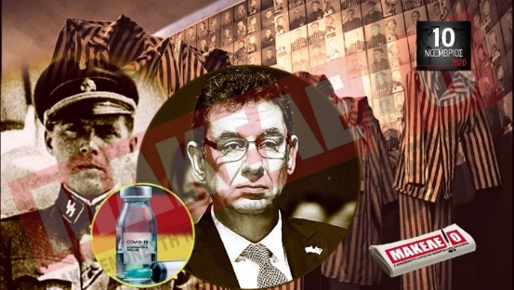
https://www.google.com/imgres?imgurl=https://kis.gr/en/files/teaser10-11%2520MAKELEIO%2520BOURLAS.jpg&imgrefurl=https://kis.gr/en/index.php?option%3Dcom_content%26view%3Darticle%26id%3D911:antisemitic-front-page-title-of-the-newspaper-makeleio-reactions-b&tbnid=p7E0cmqUzg82WM&vet=1&docid=BuoVGUxsCAtWlM&w=1920&h=1080&source=sh/x/im.

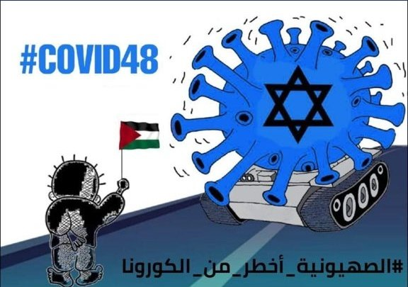

The 20 April-posted cartoon by Jordanian Twitter activist, Qutayba Abu Hammad

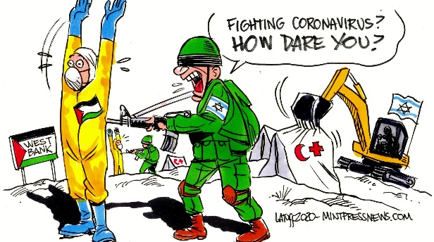
https://twitter.com/LatuffCartoons/status/1246118343075155970/photo/1.

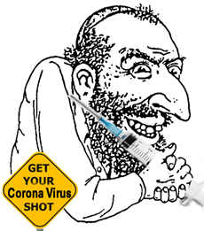
https://www.adl.org/blog/coronavirus-crisis-elevates-antisemitic-racist-tropes.
From Twitter in February and March 2020.

former French health minister Agnes Buzyn, who is Jewish, pouring poison into a well. On twitter. https://www.franceinter.fr/caricatures-complot-liste-de-noms-le-coronavirusengendre-des-attaques-antisemites-sur-le-web.

https://jcpa.org/has-the-coronavirus-infected-israelophobes/

https://en-humanities.tau.ac.il/sites/humanities_en.tau.ac.il/files/media_server/Humanities/TAU%20Spokesperon%20-%20Summary%20Coronavirus-based%20Antisemitism%20(1).pdf.
https://www.haaretz.com/us-news/.premium-soros-conspiracy-theories-play-prominent-in-attacks-against-u-s-jewish-politicans-1.9212170.
https://en-humanities.tau.ac.il/sites/humanities_en.tau.ac.il/files/media_server/Humanities/TAU%20Spokesperon%20-%20Summary%20Coronavirus-based%20Antisemitism%20(1).pdf.
https://www.gov.il/he/Departments/General/report_anti240121.
https://en-humanities.tau.ac.il/sites/humanities_en.tau.ac.il/files/media_server/Humanities/TAU%20Spokesperon%20-%20Summary%20Coronavirus-based%20Antisemitism%20(1).pdf.
https://twitter.com/hashtag/judeovirus.
https://en-humanities.tau.ac.il/sites/humanities_en.tau.ac.il/files/media_server/Humanities/PP_DP_260720.pdf.
See attached graphs, compiled by Dr. Haim Fireberg.
See report on Germany by Ms. Sarah Rembiszewski herein.
See report by the SPCJ on France herein.
https://www.nytimes.com/2020/03/20/style/zoombombing-zoom-trolling.html.
https://www.gov.il/he/Departments/General/report_anti240121. https://en-humanities.tau.ac.il/sites/humanities_en.tau.ac.il/files/media_server/Humanities/TAU%20Spokesperon%20-%20Summary%20Coronavirus-based%20Antisemitism%20(1).pdf.
See report by Dr. Lev Topor on Antisemitism on the Dark Web: Conspiracies, Communities and Actions herein.
https://www.britannica.com/topic/The-Turner-Diaries.
https://www.presstv.com/.
https://www.hsdl.org/c/conspiracy-theory-trends-qanon/.
https://www.vox.com/2020/10/9/21504910/qanon-conspiracy-theory-facebook-ban-trump.
https://www.clevelandjewishnews.com/news/local_news/ohio-leaders-groups-react-to-protester-s-anti-semitic-sign/article_184d17b0-8304-11ea-ab52-b31d5703d75d.html; https://www.ecaj.org.au/wordpress/wp-content/uploads/ECAJ-Antisemitism-Report-2020.pdf.
https://www.adl.org/education/references/hate-symbols/zog.
https://www.dw.com/en/maltese-envoy-quits-after-calling-merkel-a-nazi/a-53387702.
See report by Michal Navoth on Greece herein.
https://www.myjewishlearning.com/article/jews-and-the-african-slave-trade/.
https://www.afr.com/world/europe/why-black-lives-matter-protests-are-a-catalyst-for-anti-semitism-20200623-p555ch.
https://www.wsj.com/articles/q-a-what-is-antifa-11598985917.
https://curia.europa.eu/jcms/upload/docs/application/pdf/2020-12/cp200163en.pdf; https://www.consilium.europa.eu/media/47065/st13637-en20.pdf.
https://encyclopedia.ushmm.org/content/en/article/der-ewige-jude.
See report by Dr. Giovanni Quer on BDS herein.
Ibid.
https://www.bbc.com/news/av/world-middle-east-55000041; https://www.reuters.com/article/us-germany-bds-israel-idUSKCN1SN204.
See report on Germany by Ms. Sarah Rembiszewski herein.
https://www.jpost.com/bds-threat/antisemitic-crimes-increase-in-germany-police-report-658941.
https://www.deutschlandfunkkultur.de/studie-zu-70-jahre-nach-auschwitz-junge-deutsche-sind-des.1278.de.html?dram:article_id=310367.
https://www.dw.com/en/why-achille-mbembe-was-accused-of-anti-semitism/a-53293797.
https://www.dw.com/en/ksk-german-special-forces-company-dissolved-due-to-far-right-concerns/a-54386661.
https://www.dw.com/en/angela-merkel-laments-disgrace-of-kristallnacht/a-55548319.
https://www.jpost.com/diaspora/antisemitism/united-nations-appoints-first-un-focal-point-to-monitor-antisemitism-636863.
https://www.austria.org/the-latest/2020/2/28/austrian-parliament-presents-resolution-proposal-condemning-anti-semitism-and-the-bds-movement.
https://eurojewcong.org/news/news-and-views/global-imams-council-adopts-ihra-definition-of-antisemitism/.
https://en-humanities.tau.ac.il/sites/humanities_en.tau.ac.il/files/media_server/Hanbook%20practical%20use%20of%20the%20IHRA.pdf.
https://www.haaretz.co.il/opinions/letters/.premium-1.9480441; https://www.haaretz.co.il/opinions/letters/.premium-1.8973295.
https://www.i24news.tv/en/news/international/1612302208-biden-administration-embraces-and-champions-ihra-definition-of-anti-semitism.
See report by Michal Navoth on Greece herein.
https://www.timesofisrael.com/austrian-government-triples-security-funding-for-local-jewish-community/; https://www.jpost.com/diaspora/germany-pledges-extra-26-million-for-jewish-security-642842.
https://www.haaretz.com/middle-east-news/.premium-moroccan-schools-teach-jewish-history-in-groundbreaking-first-1.9360358.
https://berlinspectator.com/2021/02/21/germany-celebrates-1700-years-of-jewish-life-on-its-territory-1/.
https://www.govtrack.us/congress/bills/116/hr943.
https://www.worldjewishcongress.org/en/news/eu-calls-antisemitism-incompatible-with-values-demands-national-strategies-from-member-countries-12-3-2020.
https://www.reuters.com/article/uk-israel-gulf-germany/uae-minister-vows-never-again-in-berlin-holocaust-memorial-visit-together-with-israeli-counterpart-idUKKBN26R2HG?edition-redirect=in.
https://ec.europa.eu/newsroom/just/newsletter-specific-archive-issue.cfm?newsletter_service_id=1955&newsletter_issue_id=27770&pdf=true&fullDate=Sun%2012%20Jan%202020&lang=default.
https://www.prnewswire.com/news-releases/coalition-of-more-than-120-ngos-calls-on-facebook-to-create-a-comprehensive-hate-speech-policy-on-anti-semitism-301108674.html.
https://www.timesofisrael.com/twitter-tells-mks-khameneis-eliminate-israel-posts-dont-violate-its-rules/; https://www.timesofisrael.com/twitter-ceo-suggests-holocaust-denial-not-banned-on-platform-in-senate-grilling/.
Statistics – Dr. Haim Fireberg (2021). The graphs in this section refer to acts of violence, vandalism and desecration acts perpetrated directly against Jewish individuals, synagogues and community centers and against Jewish private property worldwide during 2020. The figures are based on the Kantor Database for the Study of Contemporary Antisemitism and Racism (usually accumulated from open sources and contributor special reports) and reports of the Coordination Forum for Countering Antisemitism. It should be emphasized that the graphs reflect only major violent incidents (such as arson, weapon attacks, weaponless attacks, serious threats, and vandalism or desecration).

